Functional Specification Document (FSD)
Project Name: "ConceptSnap: AI-Powered Active Recall & Mastery"
Team Name: Quantuam (Team I)
Date: 1/20/2026

Abstract
ConceptSnap is a hybrid educational platform designed to break the "Memorization Trap"—where students favor rote learning over deep conceptual understanding. Rooted in the Feynman Technique, the platform requires students to explain complex concepts in their own words. An AI-driven Diagnostic Engine then identifies knowledge gaps using semantic analysis. To ensure mastery, the platform triggers a Polymorphic Game Engine that provides subject-specific reinforcement (e.g., Physics simulations or Code puzzles). This transforms learning from passive consumption into an active, diagnostic, and gamified experience.

2. Project Overview
ConceptSnap is an AI-powered, web-based learning platform designed to break the "Memorization Trap" by using the Feynman Technique. The project aims to help students move from rote memorization to deep conceptual understanding through active recall. Students are prompted to explain complex concepts in their own words, receive diagnostic AI feedback on knowledge gaps, and engage in "Mastery Games" (simulations and logic puzzles) to reinforce their learning. By combining high-fidelity UI (Glassmorphism) with high-speed API diagnostics, the platform makes mastering STEM and theory-heavy subjects engaging and effective.

3. Objectives
- Eliminate Rote Learning: Shift student focus from memorizing facts to explaining concepts simply.
- Provide Diagnostic Feedback: Use AI to identify specific missing concepts in a student's explanation.
- Increase Engagement: Utilize gamification (XP, trophies, and interactive simulations) to motivate students.
- Support Self-Correction: Allow students to compare their thoughts with "ideal explanations" to identify knowledge gaps.

4. Target Users
- Primary Users: Students aged 12–17 (Grade 7–12) focusing on STEM and theory subjects.
- Secondary Users: Teachers and Instructors (to track classroom conceptual mastery and identify common knowledge gaps).

5. Core Features
- Student Login / User Profile: Secure access and personalized progress tracking.
- AI Diagnostic Engine: Heuristic-based analysis of student explanations.
- Subject & Topic Selection: Curated modules for Physics, Biology, CS, Chemistry, History, and Literature.
- Voice-to-Text (STT): Accessibility feature for students to speak their explanations aloud.
- Polymorphic Mastery Games: Subject-specific interactive games (Physics simulations, Code puzzles, etc.).
- Explanation Comparison: Side-by-side view of student input vs. an expert ideal explanation.
- XP & Rewards System: Gamified progression with XP and visual "trophy" rewards.
- Progress Tracking: Visual reports on mastered vs. struggling concepts.

6. Feature List
Feature | Description | Inputs | Outputs | Priority
Login & Profile | Students log in to save their XP and mastery history. | Username, Password | User session, XP total | Must-have
Topic Selection | Choose from 11+ expert-curated topic profiles. | Subject/Topic ID | Selected module data | Must-have
Explanation Input | Students write or speak an explanation of the concept. | Text/Voice input | Normalized text string | Must-have
AI Diagnosis | Compares semantic distance to identify missing concepts. | Student text | Feedback on gaps, XP awarded | Must-have
Mastery Games | Subject-specific reinforcement (e.g., Physics simulation). | Game interactions | Success/Failure state, 50 XP | Must-have
Ideal Comparison | Shows the student an "Ideal Explanation" for self-correction. | Request comparison | Side-by-side text view | Must-have
Voice Features | Read-aloud (TTS) and voice input (STT). | Voice command / text | Audio output / transcribed text | Nice-to-have
Progress Reports | Visual dashboard of mastered topics. | User history data | Mastery charts, topic status | Must-have
Retry Loop | Allows students to re-explain based on feedback. | Updated explanation | New diagnosis & score | Nice-to-have

7. User Scenarios
- Scenario 1: Active Recall (The Core Flow) Aarav selects "Physics → Newton's First Law" → types an explanation → AI identifies he forgot to mention "Inertia" → Aarav learns from the feedback.
- Scenario 2: Mastery via Simulation Sita explains "Chemical Equilibrium" → AI validates her understanding → SITAs is unlocked to play a "Balance the Equation" mini-game → earns 50 XP.
- Scenario 3: Auditory Learning A student uses the "Voice-to-Text" feature to record their explanation of the French Revolution → the system reads back the "Ideal Explanation" using TTS.
- Scenario 4: Self-Correction Student provides a vague explanation → clicks "Compare" → realizes the expert explanation uses key terms they missed → retries the explanation.
- Scenario 5: Tracking Mastery A teacher views the dashboard and sees that 70% of the class has mastered "Photosynthesis" but is struggling with "Cellular Respiration."

8. Required Screens/Pages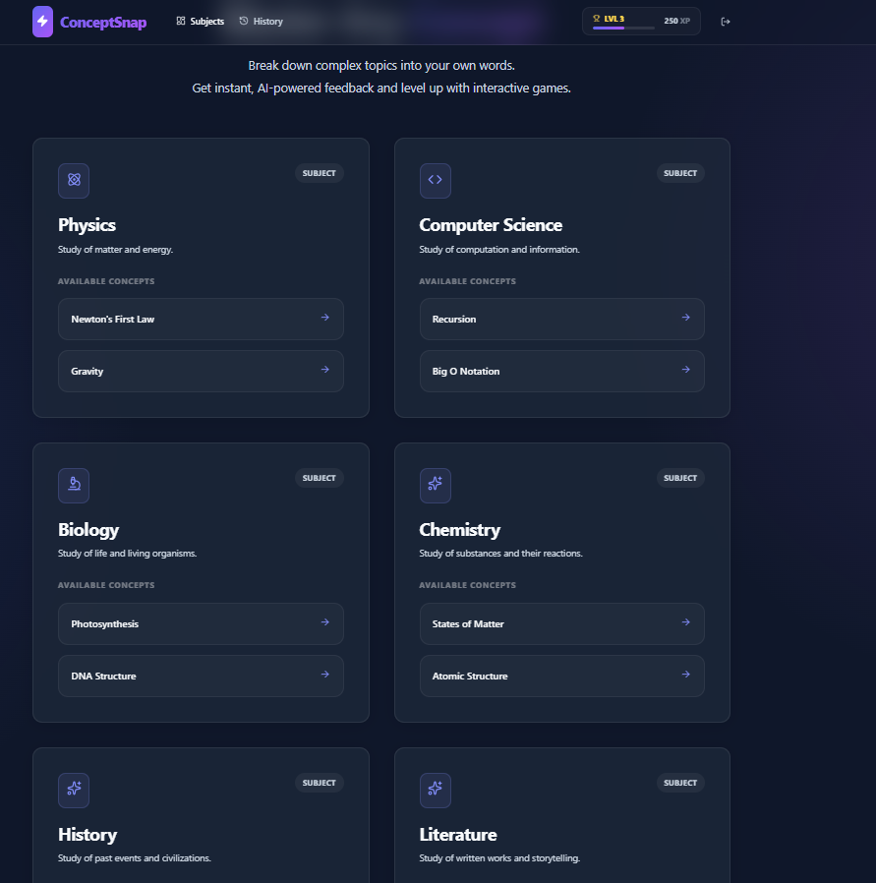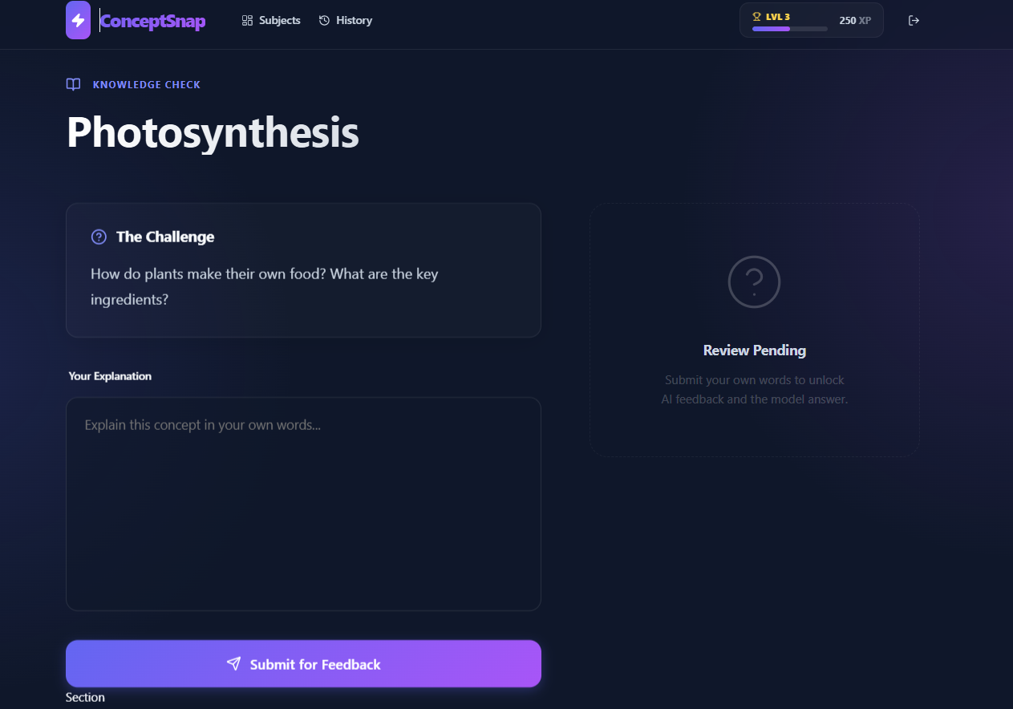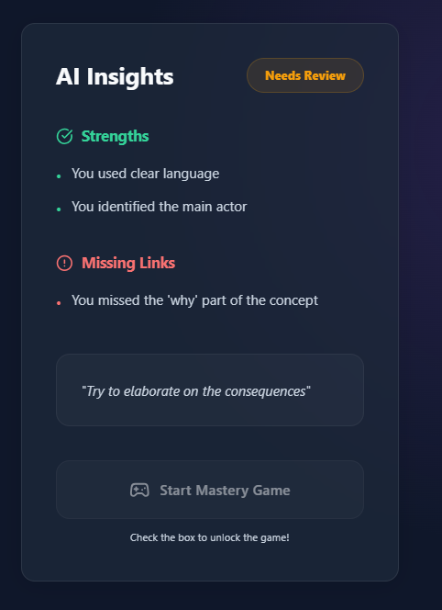

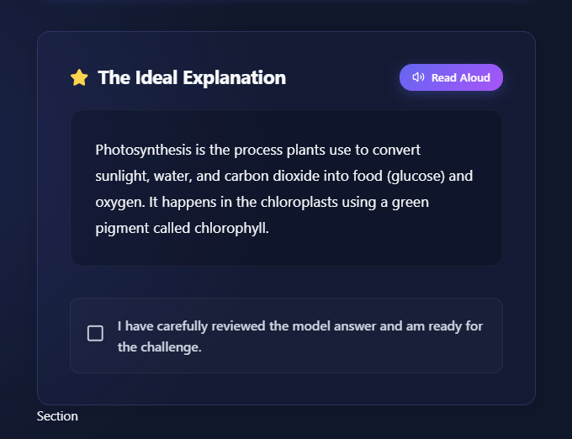

Reference:
- Research Article: The Impact of an AI-Based Dynamic Feedback System on Student Academic Performance (ResearchGate, 2025). This finding underscore that AI feedback systems improve academic performance by providing timely, personalized, and actionable insights.

- Impact on Engagement: Studies by Luckin et al. (2016) show that intelligent tutoring systems that analyze learning patterns can bridge knowledge gaps more efficiently than traditional instruction.

- How People Learn: Brain, Mind, Experience, and School by the National Research Council. This book explains that experts possess "conditionalized" knowledge—meaning they don't just know facts; they understand when and why to apply them.

- The impact of conceptual versus memorization-based teaching methods on student performance (Journal of Emerging Investigators, 2025). This research indicates that concept-based learning leads to more consistent student performance and better long-term retention compared to rote learning.

